Extended Data Modeling and Governance
Name
Institution
Date

Extended Data Modeling and Governance
Extended data governance provides an opportunity to accomplish the three interrelated missions. Robust data governance structures merit because of the ability to provide proactive management capabilities using a defined set of rules (Hoffer, Venkataraman, & Topi, 2016). Secondly, data governance guarantees the continuity of the service because of the ability to provide services to the stakeholders (ibid). Lastly, an effective data governance model merits because of the reactive management approach, which facilitates a design manager to resolve non-compliance issues (ibid). Therefore, the complexity of the data and intricate interactions with myriad stakeholders necessitates Amazon to initiate robust data governance structures.
Equally, data modeling is another integral element of database design methodology that serves myriad obligations. The notable duties of a sufficient data modeling are to ensure normalization of a logical database, development of physical design plan, and development of a technical plan that addresses the architectural needs of Amazon’s data governance structure (Hoffer, Venkataraman, & Topi, 2016). Database modeling using logical design entails a transformation of the conceptual requirements for the data storage using distinctive specifications.
The first form of specification focuses on achieving compatibilities with the specific database management system (DAMA International, 2010). The second form of specification concerns with the physical requirement that defines the parameters for storage to be used as an input element for the implementation of the database (Hoffer, Venkataraman, & Topi, 2016). The two models of specifications provide an opportunity to understand the Amazon.com data requirements and express them in a correct technical language. The subsequent report addresses the two form of specification because it entails mapping of the conceptual requirement to logical database design, development of physical database design, and development of the commensurate technical plan.
Mapping the Conceptual Requirements to a Logical Database Design
Development of logical design involves the transformation of the Enhanced Entity-Relationship (EER) model to represent the complex data governance. An EER model is a reliable tool used to represent the conceptual requirements of an organization (Hoffer, Venkataraman, & Topi, 2016). Specifically, an EER model depicts the cadres of super-type and subtype relationships that exist among the data constructs (Loudon & Loudon, 2014). A super-type construct represents the general entity data that contains inheritable attributes (ibid). Subsequently, the subtypes are the specialized data entity that inherits the multiple attributes of a general super-type (Hoffer, Venkataraman, & Topi, 2016). The entity clustering process becomes an essential process because it integrates a hierarchical decomposition of the hundreds of entities to create an EER model (ibid). Therefore, the ability to group the existing entities and relationships using hierarchical decomposition merits because it facilitates a design manager to accord attention to the most important details of the model. Chart 1 below is a model of EER that depicts the primary attributes and relationships of the super-types and subtypes data constructs for the Amazon.com, Inc.
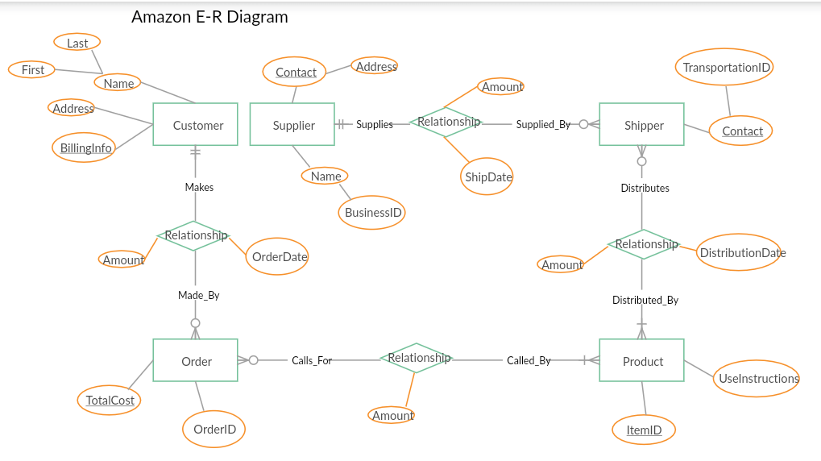
The relational table above illustrates types of relationship that exist among the CUSTOMER, SUPPLIER, SHIPPER, PRODUCT, and ORDER. The boxes depict the five entities with the line used to demonstrate the type of relationship (Loudon & Loudon, 2014). A one-to-many type of relationship entails a line connecting two entities, which end with a crow’s foot topped by a short mark (ibid). A one-to-one relationship is another common type of relationship between entities that entails line that ends in two short marks (ibid). The goal of identifying the five entities and respective relationships is to influence the understanding of the data to construct for the Amazon.com, Inc. (ibid). Moreover, the relationship and data entities affect the effectiveness of relational logical data modeling. The tables below reveal the relational database defined from the EER Model
Customer table
Customer name | First Name | Last Name | Address | BillingInfo

Shipper table
Transportation_ID | contact | Ship date | Amount

Product table
Item_Id | User instruction | Distribution date | amount

Order table
Order_Id | cost | Order date | Amount

Normalization of the Logical Database
Normalization process aims to decompose the relations that exhibit anomalies to achieve structured and stable relations. Consequently, the relational tables above exhibit multivalued attributes that necessitate a breakdown of the respective table and use of primary keys to achieving both the first normal form and second normal form.

Customer_id | First Name | Last Name | address
Billing table
BillingInfo | Customer_id

Normalized shipper’s table
Shipper_id | Contact | amount
Supplier-distribution table
Distribution date | Supplier | Shipper_id

Research on the Data-Type in the DBMS
Amazon Relational Database Service (Amazon-RDS) is a data governance structure used to facilitate the delivery of effective services, which include Amazon Web Services’ cloud-computing services. Amazon RDS structure merits as an architecture platform because of the ability to support multiple data types to meet the different needs of the consumers (Loudon & Loudon, 2014). The common types of relational database services available include the MYSQL, SQL Server, and Oracle Database (ibid). Diversification of the caliber of data type supported in Amazon RDS improves the quality and capability of the database management system (DBMS).
Specifically, the Amazon RDS is a model of relational database architecture appraised because of the ability to accomplish three operations. The critical data development operations include the select, join, and project, which is useful in the development of multiple sets of data (Loudon & Loudon, 2014). The three operations also determine the data type for the entire attributes identified in the Amazon RDS database. First, the select operation concerns with the creation of a subset that contains the records that meet the defined criteria (ibid). The select operation creates the subset of the rows attributes as per the defined criteria. Secondly, the join operation facilitates a designer to combine the relational tables and yield more information (ibid). Lastly, a project operation facilitates the creation of a subset of the column in a table that meets the specification of the users (ibid). Therefore, the three operations specify the cadres of specification and generalization of the types of data structure supported in the Amazon RDS system. Particularly, the Amazon RDS is designed to supports the relational-based data types found in conventional DBMS and engines.
Physical Design Decision for the Amazon.com
Besides analyses to determine the conceptual requirements and logical design, another element that necessitates decision-making is a physical design model. A physical design influences the arrangement of the database on the storage devices, which are accessible to the users (Loudon & Loudon, 2014). The core aspects of decision-making include designing fields, de-normalization aspects, partitioning, and file organization (Hoffer, Venkataraman, & Topi, 2016). The four aspects of decision-making that relates to physical database design influence the storage format, instruct the DBMS about the group attributes and enhances the querying performance.
First, a physical database design focuses on the designing field as a key element that influences the mapping capabilities. The designing field aspect entails decisions that concern with the mapping of the attributes of the data in a logical database model using a coding schema (Hoffer, Venkataraman, & Topi, 2016). The type of coding schema that a designer integrates hinges on the DBMS to harness the compatibility of the designing fields. A notable designing field evident in an MS Access caliber of DBMS is the use of NUMBER FIELDs to represent the use of single field-size, double field-size, or text (ibid).
Secondly, the de-normalization aspect of physical database design has a goal to improve the processing performance of Amazon RDS. Hoffer, Venkataraman, & Topi, define de-normalization as a process of undoing the normalized relation to form a non-normalized physical record (2016). De-normalization is applicable when the entities have a one-to-one of many-to-many types of relationship. Thirdly, partitioning is another aspect of physical database design that facilitates a designer to integrate a horizontal-based or vertical-oriented mapping of the rows and columns respectively in relational logical modeling (ibid). Partitioning aims to redistribute the rows or columns into distinctive physical records.
Lastly, a decision to enhance the physical database design relates to file organization to arrange the partitioned records in a physical storage module. The file organization aims to bolster the speed of retrieving files, processing, and maximize the storage spaces (Hoffer, Venkataraman, & Topi, 2016). Multiple approaches used to enhance file organization include sequential file access, indexing, and hashed filing (ibid). Specification on the positioning of a file is a strategic decision that improves the use of storage space in a DBMS.
Screenshot Evidence of the Implementation of the Database
Figure 2 below reveals the use of MS Access, which represents a rudimentary tool to display relational-base data.
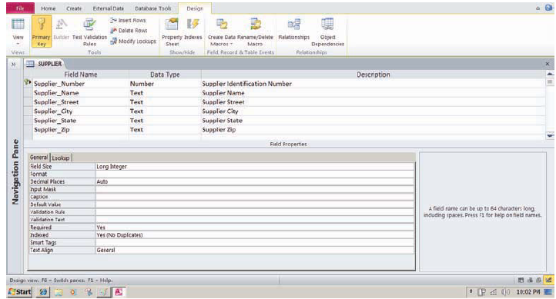
Technical Plan for the Data Governance
Data governance refers to the procedures that an organization institutes to influence the management of the data. Therefore, an effective technical plan adheres to the stipulated set of processes and procedures to enhance availability, integrity, and compliance (Hoffer, Venkataraman, & Topi, 2016). Amazon.com has an elaborate technical plan that addresses the architecture management function within the organization. The Amazon Relational Database Service (Amazon RDS) is a profound technical plan that influences the ability to achieve proactive management capabilities and guarantees service continuity (Loudon & Loudon, 2014). Further, the Amazon RDS technical plan also entails reactive structures that facilitate the management to resolve issues that emanate from non-compliance.
References
DAMA International. (2010). The DAMA Guide to the data management body of knowledge (DAMA-DMBOK), First Edition, Technics Publication
Hoffer, J., Venkataraman, R. & Topi, H. (2016).Modern database management, (12th Edition), Pearson
Loudon, J. & Loudon, K. (2014). Management Information System: Managing Digital Firm, (13th Ed.), Boston; MA, Pearson

